PROJECT GUIDANCE DOCUMENTS

Introduction to the Bowtie methodology:
A ‘bowtie’ is a diagram that visualizes the risk you are dealing with in just one, easy to understand picture. The power of the bowtie method lies not just in creating the diagram, but in using it as a dynamic tool for ongoing risk management and communication
The model gets its name from its distinctive shape, which resembles a bowtie when fully constructed.
The key components of a bowtie model include:
- Hazard: The central element that has the potential to cause harm.
- Top Event: The point at which control over the hazard is lost.
- Threats: Potential causes that could lead to the top event.
- Consequences: Potential outcomes if the top event occurs.
- Barriers: Preventive and mitigation measures to control risks.

Barriers can be Active or passive and group by:
- Hardware
- Hardware – Human
- Human

    - https://www.wolterskluwer.com/en/solutions/enablon/bowtie/expert-insights/barrier-based-risk-management-knowledge-base/the-bowtie-method
- https://www.wolterskluwer.com/en/solutions/enablon/bowtie/bowtiexp?compositeLink=%7BD9077CFD-14F0-4BDC-BABE-FB69AB98F961%7D

- BOWTIE METHOD: ELEMENTS AND SYMBOLS

- BOWTIE SYMBOLS AND ELEMENTS EXPLAINED (RULES)
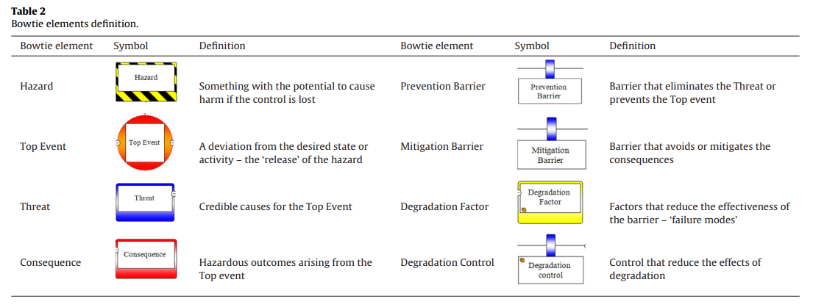

EXAMPLE – DRIVING A VEHICLE IN A HIGHWAY
Driving a vehicle in a highway is a Hazard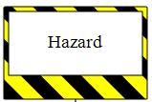. Hazards are operations, activities or materials WITH THE POTENTIAL TO CAUSE HARM. In this case ‘Driving a vehicle in a highway is a hazardous activity with the potential to cause Harm (e.g. death, damage)’. Harm can occur if the control over the hazard is lost and hazard is ‘released’. Hazards are usually part of normal business, in our example: ‘Driving a vehicle in a highway’. The hazard is ‘released’ when the control over the hazard is lost. This happens when the driver losses the control over the vehicle. Therefore, the Loss of Control Over the Vehicle represents the Top Event 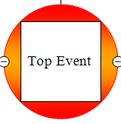, i.e. the moment in which the control over the HAZARD is lost. It is a deviation from the normal business activity and happens before the real harm, i.e. the Consequence 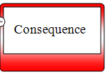occurs. A Consequence is defined as an undesired hazardous outcome that could arise from the TOP EVENT, for example a DEATH can result from the vehicle impacting other vehicles or objects.
Now, the Consequence can be either be lessen or its likelihood of occurrence reduced if we put MITIGATION BARRIERS 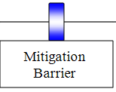 , for example, the use of a safety belt can prevent the driver from impacting the internals of the vehicle and dying as a result, or driver’s defensive driving skills may otherwise prevent the vehicle from impacting other objects or vehicles, thus REDUCING THE LIKELIHOOD OF the vehicle impacting other vehicles or objects.

On the other hand the Top Event (Loss of Control) can result from THE OCCURRENCE of THREATS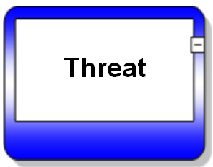. One THREAT, for example, can be associated with intoxicated or impaired driving. Intoxicated driving can lead directly to a LOSS OF CONTROL OVER THE VEHICLE. The 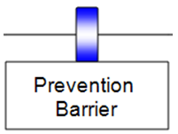 PREVENTION BARRIERS shown on the left hand side of the bow-tie are systems designed to PREVENT the THREAT from occurring or to stop a TOP EVENT from developing from these THREATS. For example, the use of A DESIGNATED DRIVER can PREVENT the THREAT from occurring while the LANE DEPARTURE WARNING SYSTEM can prevent the THREAT from leading to the TOP EVENT.
On both sides of the bow-tie, the prevention and mitigation barriers can be subject to ‘degradation’, i.e. they may not work when called upon to do so. For example, if BREATH ALCOHOL IGNITION INTERLOCK DEVICE is poorly calibrated then it will not function correctly and, as a result, the threat will lead to a TOP EVENT. Or, if the driver refuses to wear the safety belt, the SAFETY BELT will not be present and then the likelihood or the severity of the CONSEQUENCE will increase.

